Question 2:
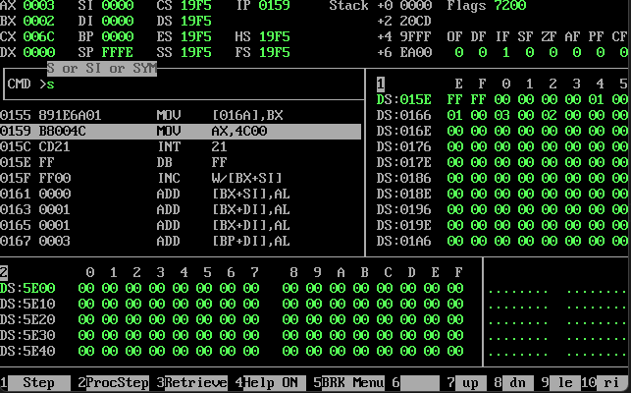

Question 1:
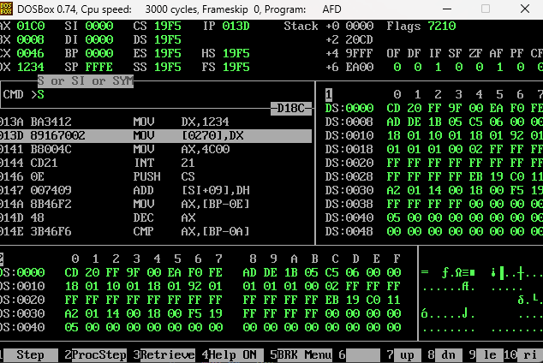

Q3
- Register Addressing
- Immediate addressing
- When you have a register and want to extract contents of a memory location
- It allows you arrays in memory
- Bx and cx
- Immediate addressing
- Offset and base indexes
- It allows you to access 2 memory locations like in this [[bx]]
- Indirect Addressing
- Allows accessing two registers at the same time

